

**INDIAN NATIONS COUNCIL, BOY SCOUTS OF AMERICA**



TABLE OF CONTENTS

Important Dates Page 2

Why Participate Page 3

Sales Methods Page 4

Product Line Up Page 5-7

Leading your Unit Page 8

Kernel Checklist Page 9

Annual Progrtam Planner Page 10

Setting Goals Page 11

UNit Kickoff Page 12

Tips for Making sales Pop Page 13-14

Handling Objections Page 15

Storefront Sales Page 16

Ordering & Inventory Page 17

Popcorn Pickup Page 18

UNit Commission & payment Page 19

scout incentives Page 20

$1,500 club Victory party page 21

camp masters incentives page 22

important contacts page 23



Important dates

Council Mail Take Order Forms Online Sales Open

**Council Popcorn Kickoff Unit Show & Sell Orders Due Take Order Sale Begins Staff/Volunteer Sorting Popcorn Pickup**

**Popcorn Pickup**

**Unit Take Orders Due**

**Show & Sell Returns Deadline Show & Sell Money Due**

**Unit Prize Orders Due Staff/Volunteer Sorting Popcorn Pickup Popcorn Pickup**

**Take Order Money Due**

**$1500 Club Victory Party**

Wed, July 24th Sun., July 28th Wed., July 31st

Wed., August 7th Wed. July 31st Thu., August 29th Fri., August 30th Sat., August 31st Wed., October 16th Wed., October 16th Tue., October 22nd Tue., October 22nd Thu., November 7th Fri., November 8th Sat., November 9th Mon., December 2nd Sat., December 7th

campmasters.org, 11:00 pm Scout Resource Center, 6:30 pm campmasters.org, 11:59 pm

Important dates

Premier Logistics, TBD

Premier Logistics, 3:30 -7:00 pm Premier Logistics, 8:00 am-12:00 pm campmasters.org, 11:59 pm

Scout Resource Center, 5:00 pm Scout Resource Center, 5:00 pm Scout Resource Center, 5:00 pm Premier Logistics, TBD

Premier Logistics, TBD Premier Logistics, TBD

Scout Resource Center, 5:00 pm Incredible Pizza Co., 11:00 am



The annual popcorn sale remains an excellent opportunity for Scouts and units to fund their entire year of Scouting. With the rising cost of membership fees, a successful popcorn sale is critical to the stability of our units. All proceeds stay right here to help support local Scouts. That’s 73% that goes to Scouting. While a portion of that goes to directly support your Scout unit, the remaining portion gets reinvested into supporting your unit, and into local programs and supplies. So by selling, you not only help your unit, but you help Scouting as a whole. **That means new equipment at camp and enhanced facility improvements so that your unit can enjoy every moment of their stay.**

When participating in popcorn, Scouts gain self-conﬁdence, people skills, money management, salesmanship, and business ethics – things that help prepare them for life! These are great values and skills for youth to learn.

**Communication & Public Speaking**

Many of us have experienced an early school memory of getting up in front of the classroom to do a presentation or oral report only to freeze and forget everything that we had prepared. This is because we allowed our nervousness and self-doubt to creep in and take over instead of being confident about what we had to say. And even as adults, many of us still dread the act of public speaking and debate. That’s why mastering the art of public speaking should be taught to children. The skills we learn from public speaking tie directly into our everyday lives and are often the foundation of successful communication, leadership, and performance. Whether it’s in our career paths or personal relationships, public speaking skills have a huge impact.

##### Builds and Improves Confidence

Mastering the art of public speaking empowers Scouts to view themselves in a different, more positive light. It helps them learn practical communication skills, ultimately boosting self-confidence and other soft skills. Having a positive self-image enables Scouts to talk more easily and naturally, which will help those who are inherently shy in nature. **Once your Scouts starts public speaking, they will feel like they are delivering value to their audience, which in turn helps them develop faith in themselves and provides a sense of pride in their work.**

##### Salesmanship & Entrepreneurship

Learning to set and reach goals through action helps Scouts develop important business skills. They learn how to best represent themselves and persuade others. In the future, they can use these tools to gain funding for a revolutionary business idea or be a strong team leader within their organization.

3



### The most successful units use all methods!

##### Show & Sell

Set up a Show Sell booth at a storefront or high foot traffic location.

Contact store or location to obtain permission to set up a Show Sell booth. Popcorn Kernel should set up a schedule for Scouts with specific times of participation. Scouts should wear their uniforms and have a speech prepared for when approaching customers. Sales credit can be split up among Scouts for prizes.

##### Show & Deliver

Take Show Sell product door-to-door, also known as Show & Deliver or Wagon Sales.

Most effective sales method that involves the Scout soliciting orders at the customer’s residence. This method is preferred for neighborhoods close to home. If the desired product is not on hand, an order can be taken, and product delivered later. Use a wagon to tote around the popcorn, making it a quick and easy process for the customer! **Many homeowners say that no Scout has ever come to their door, missing this great opportunity!**

SALES METHODS

##### Take Order

Door-to-Door Sales

Scouts utilize the order form for customers to place an order for product. The Scout turns in the order form to the unit’s Popcorn Kernel. The product is then ordered and delivered later. Units will pick up the order from the Council’s pickup location and distribute it to Scouts.

Scouts will be responsible for delivering the product in a timely manner. It is up to the unit to decide if money will be collected at the time the customer places the order or when the product is delivered.

##### Corporate Sales

There are many ways to sell popcorn to businesses. Some businesses will allow you to sell to their employees and some will let you post an order form in a lobby or break room. Focus on companies who give out year end or holiday gifts to employees or customers. Banks, insurance agents, car dealers, doctors, dentists, and realtors are all good examples. If a company is interested and needs assistance with special ordering, please contact the Scout Resource Center.

##### Online Sales

Join the thousands who’ve raised over 12 Million for their Scouting adventures! Scouts can create their own online fundraising page and share it with family and friends via email, social media, and text message. Family Friends are able to visit the Scouts fundraising page and place orders on their behalf. The product is shipped directly to the Scouts family/friends It’s a great way to reach family and friends outside of your community!

4



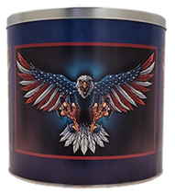 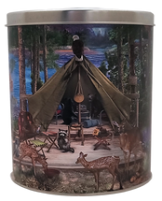

Show and Sell Products

3 Way Cheesy Cheese

$50

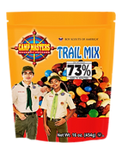

Classic Trail Mix

$25

Supreme Caramel Corn

$30

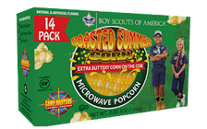

14 Pk

Roasted Summer Corn

$20

22 Pk

Movie Theatre Butter

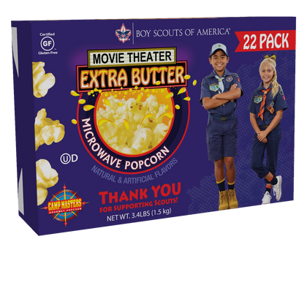

$35

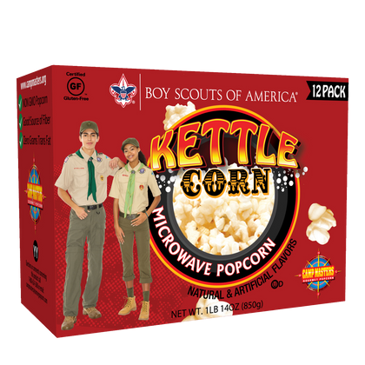

12 Pk Kettle Corn

$20

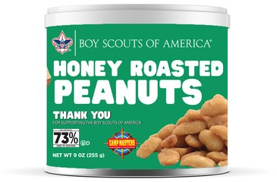 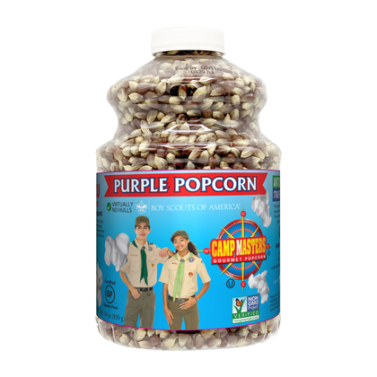 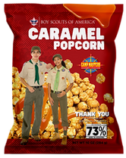

#### 12 oz.

Honey Roasted Peanuts

$20

Purple Popping Corn

$15

Caramel Corn

$15

**NEW PRODUCTS THIS YEAR**

Salted Cashews

$30

White Cheddar Popcorn

$20



Show and Sell Products

6

Take Order Products

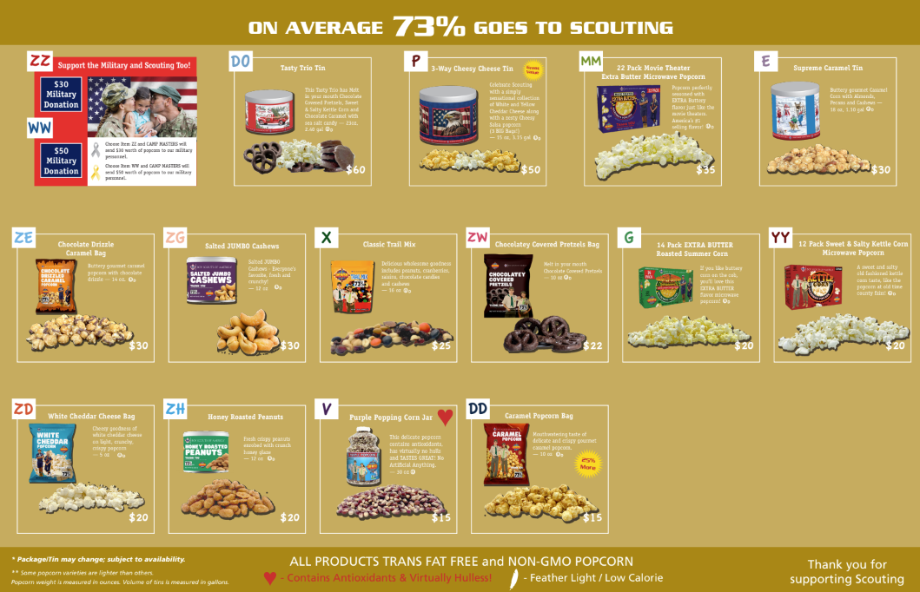



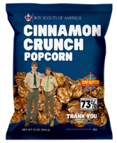

3 Way Cheesy Cheese

$56.50

ONLINE PRODUCTS

22 pk Movie Theater

$46.50



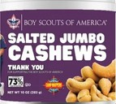  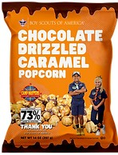

Salted Jumbo Cashews

$41.50

Supreme Caramel Corn

$41.50

Choc. Drizzled Caramel

$41.50

  

Cinnamon Crunch

$36.50

14 pk Roasted Summer Corn

$36.50

12 pk Kettle Corn

$36.50

White Cheddar Cheese

$36.50

  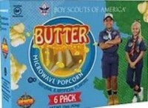

Honey Roasted Peanuts

$36.50

Caramel Corn Bag

$31.50

Purple Popping Corn

$31.50

6 pk Butter

$26.50

7



The **Popcorn Kernel** oversees operations of the Unit’s popcorn sale. This is an important leadership role within the Unit. The Popcorn Kernel ensures distribution, promotion, reporting and payments for Unit’s entire sale period. They also work closely with their Unit committees and District Popcorn Kernel.

The best part is leading their #PopcornSquad in the Unit’s goals for the sale.

This includes:

Encouraging Scouts to Earn Their Way Developing the Overall Sale Strategy for the Unit

LEADING YOUR UNIT

Establishing Relationships with Community Businesses Helping Parents Support Their Scout

Guiding the Unit’s Progress to Their Sales Goal Gathering and Distributing Important Information Running Logistics for Product and Sales Earnings Rewarding Scout Eﬀorts with Great Prizes Hosting an EPIC Unit Kick-Oﬀ Celebration

**Your #PopcornSquad includes (**based on your Unit and District Size**):**

District Popcorn Kernel - Your right-hand in all things popcorn

Unit Committee Members - Helping you develop the plans and budgets Assistant Popcorn Kernel - Your left-hand in all things popcorn

Kickoﬀ Kernel - Your party planning partner

Show-N-Sell Kernel - Your logistics coordinator (preferably with a truck!) Pickup Kernel - Your warehouse watchdog for product inventory

Prize Kernel - Your fun-lovin’ prize patrol buddy

Communications Kernel - Your social media / email master spreading popcorn love

As exciting as these position titles are, people tend to more receptive when asked to execute a speciﬁc task, not just serve a role in the popcorn sale. **When asking for help, be sure to say what you speciﬁcally NEED help with and how much time you think it will take them.**

##### Tip

For example, instead of: Hey Sarah, will you volunteer as Kickoﬀ Kernel this year?

Ask: Hey Sarah, your creativity and crafting skills are top notch. Would you help me with decorations and games for the Popcorn Kickoﬀ? I’m thinking it will take us about 5 hours in planning and decorating day of, plus whatever time you’d estimate for creating them.

18



Kernel checklist

**My #PopcornSquad**

❏ Attend Popcorn Trainings

KERNEL CHECKLIST

❏ Plan Annual Scout Program (w/ Unit Commitee)

**District Kernel** Phone Email

❏ Review Commission Structure & Prizes

❏ Determine Additional Unit Prizes

❏ Set Budget for Program (Use Unit Fillable Budget)

**Assistant Kernel** Phone Email

❏ Recruit Your #PopcornSquad

❏ Update Scout Roster (w/ Membership Chair)

❏ Direct Scouts to Self-Register or Update Bio

❏ Determine Per-Scout Fundraising Goal **(Use Scout Goal Worksheet)**

**Kickoff Kernel** Phone Email

❏ Secure Storefronts (as / where possible)

❏ Create Unit Timeline for Popcorn Sale

**Show-N-Sell Kernel**

Phone Email

❏ Establish Guidelines for Popcorn Pickup, Returns & Money

❏ Conﬁrm Show-N-Sell Locations & Times

❏ Prepare / Update COVID-19 Guidelines

❏ Place Unit Popcorn Order

**Pickup Kernel** Phone Email

❏ Host Unit Kickoff Meeting

❏ Prepare and Distribute Handouts

❏ Share Tips & Ideas for Selling Popcorn

❏ Provide Selling Incentives & Games for Scouts

**Prize Kernel** Phone Email

❏ Coordinate Pick-Up / Drop-Offs at District Warehouse

❏ Encourage Scout & Parent Participation

❏ Share Selling & Marketing Strategies

**Communications Kernel**

Phone Email

❏ Help Scouts Share Their Online Selling Link

❏ Place Final Popcorn Order

❏ Order and Distribute Prizes

❏ Remit Product Payments to Council

❏ Contact District Kernel as Needed for Assistance

❏ Celebrate!

# Image preview

**Annual Program Planning guide**

10



**A Per-Scout goal is a lot like a merit badge or skill requirement.** In Scouting, we often tell Scouts that to receive an award, they must "do, tell, show, demonstrate, etc." All Cub Scouts are held to the motto of "Do your Best." Scouts want to succeed. Helping them to succeed in the popcorn sale for the health and strength of the unit is no diﬀerent. We simply need to be able to help our Scouts deﬁne success. Use the formula below to help you set unit and Scout goals. Be sure to ask your Unit Treasurer and Unit Committee to help prepare your budget and popcorn sales goals.

##### Goal Setting Formula

**Setting goals**

|  |  |
| --- | --- |
|  |  |
|  |  |
|  |  |

Set a unit goal ( 2%-5% increase) Set a per Scout sales goal

Communicate the per scout goal at the unit kick-oﬀ

After sharing the goal, highlight what the unit goal pays for and how that beneﬁts each Scout

Remind scouts and parents of the Unit and Per Scout goal throughout the sale. Reward Scouts for achieving the Per Scout Sales Level.

Encourage all Scouts and families to participate and achieve the per Scout goal. Develop unit incentives to encourage Scouts and families to sell.

If you’re not setting goals in sales and in life, then you’re letting someone else dictate the path. By setting [**SMART goals**](https://www.youtube.com/watch?v=xBknBurcDwU), you have something to strive for which helps you push and measure your progress. Set a speciﬁc goal to sell 20 bags in an hour which was an increase in your previous outing where you sold 15 bags. This was your short-term goal which aligned with the larger goal of selling 750 bags of popcorn. With this goal in mind, you will end of crushing your goal.

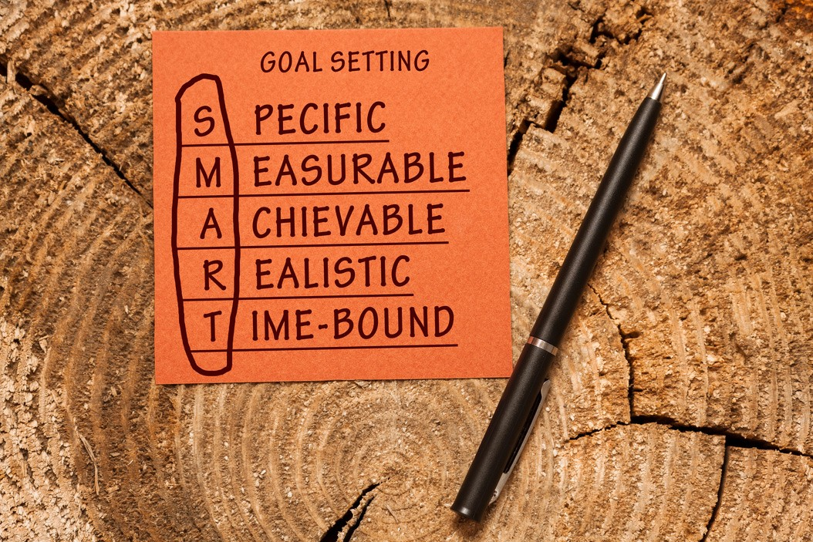



**A great popcorn sale starts with a great popcorn kickoff!** Follow these simple steps to start your popcorn sale with a BANG and motivate your Scouts, parents and other volunteers.

1. **Set the Agenda.** Think of things that are fun and fast paced. This helps build energy and excitement for the popcorn sale. Scouts will leave ready to earn their way selling delicious popcorn!
2. **Ask for Help.** Enlist others to help you pull off a fun and exciting popcorn kickoff! No need to try and take it all on yourself.
3. **Know Your WHY.** Share the exciting Scouting Program that this fundraiser will support. Talk about the activities and what the Scouts will experience and reiterate that it can all be paid for by POPCORN!
4. **Review the Forms.** Show Scouts the forms they’ll be using in detail so they understand how to use them to promote the products and capture orders.

Unit kickoff

1. **Build their Profile.** Have each Scout register or update their profile at CAMPMASTERS.org.
2. **Ready to Sell!** Add CAMP MASTERS to their phones.
3. **Sharing is Caring.** Explain how they can share their CAMP MASTERS profile link with friends, family, and through social media.
4. **Cover What’s Critical.** Spend some time explaining the different ways to sell, key dates for the program and show and sell locations.
5. **Focus on the Goal.** Motivate Scouts to take on the Unit Scout goal and to pick an awesome prize as part of their goal!
6. **Create a Memory.** End the night with a fun and memorable event! Scouts love to be part of the action. And they always love a good pie to the face of their Unit Leader!

##### Sample Kickoff Agenda

Grand Opening (5 mins)

Play music, dim the light and have fun!

Share your Scouting program & promote upcoming adventures (10 mins)

Make sure families understand the benefits of selling popcorn and how it pay for their program.

Highlight key dates that are important to the popcorn sale

Train your Scouts (10 mins)

Explain the different ways Scouts can sell: Show-N-Sell, Show & Deliver, Take Order. Digital Take Order and online at CAMPMASTERS.org

Showcase your Scout Rewards (5 mins)

Introduce your unit incentive program, including the CAMP MASTERS High Achiever program.

Big Finish

Have top sellers from last year spray the leaders with silly string. Send everyone home motivated to sell.

Keep it FUN! Keep it MOVING! Keep it SHORT!



**SELL SELL SELL.** Keep Scouts motivated! Do one fundraiser per year and do it well! Some ideas to keep Scouts motivated: arrange den/patrol competitions, continuously share what prizes and incentives are available at each sales level, remind parents about how the popcorn sale pays for their program, and give regular updates on your unit’s progress towards your sales goal.

TIPS FOR MAKING SALES POP

**FIND A HOOK;** Make the sale fun. The scouts that have the most success are the ones that view this as FUN way to earn and win cool prizes, help their Pack or Troop, and have some friendly competition with their fellow Scouts. Leaders should make sure to create a fun and supportive environment that rewards sales success while supporting every Scout's efforts regardless of their sales.

**CREATE A GOAL.** Units that have a written down and expected goal sell more. Scouts who either have a goal assigned by the unit OR one they've selected sell **MUCH** more.

**INSPIRE COMPETITION.** Award a special prize to the Den or Patrol that has the highest average sales per Scout, award trophies, or ribbons to the Individual Sales leaders in each Den or Patrol.

**WEAR SCOUT UNIFORM.** The Popcorn & Adventure Card fundraisers are the only approved fundraisers that Scouts may wear their uniform. Everyone loves to support a Scout in uniform!

**SET UP SHOW & SELL DATES EARLY.** Time slots at businesses go fast! Begin to request date/times in the summer before school starts. Think "outside of the box" for locations!

HAVE ORGANIZED NEIGHBORHOOD CANVASSING OR “BLITZ” DAYS. Have Scouts

meet with unit popcorn in a parking lot or nearby location with designated streets for each den, patrol, etc. to canvass. If the Scouts have the product, they don't have to return to the house and the customer gets their product at the point-of-sale (Show-and-Deliver).

DECIDE IN ADVANCE HOW YOUR UNIT IS GOING TO DIVVY UP SALES. Either give

each Scout an equal share or pro-rate on a time basis.

**HAVE UNIT LEVEL REWARDS.** Some ideas: gift cards for top seller or top den(s)/patrol(s), pie in the CM/SM face, free camping trip, dues refunded, special unit activity if they sell above X dollars, free pizza party for the highest selling den, etc. Find freebies at local stores such as free oil change, free massage, free day spa, etc. for the parents! Parents who are motivated will get their scouts selling.

**ACCEPT CREDIT CARD PAYMENTS.** No cash, no problem! Having a method to accept credit card payments can drastically increase sales. It alleviates the customers response of "I don't have any cash."

**COMMUNICATE WITH SCOUTS AND FAMILIES OFTEN:** Check up on how they are doing, keep them informed of the great CAMP MASTERS rewards and unit incentives.

GIVE YOURSELF ENOUGH TIME TO COLLECT MONEY AND PLACE ORDER. Make the

forms and money due to the Den Kernels or Patrol Kernels about a week before you have to place the order. The Assistant Kernels then give you what they collected several days before so that you can get everything in order, allowing time to track down Scouts who sold but you have not received their form.

**PRACTICE, PRACTICE, PRACTICE! Have your scouts practice and memorize the following script to maximize sales.**

Sales Script & Tips

"Hi Sir/Ma'am, my name is . I'm a Scout with Pack/Troop # . We're selling popcorn to help raise money for our Pack/Troop. You can help us by trying some of our delicious popcorn.

You'll help us, won't you?"

##### Selling Tips

ALWAYS wear your uniform.

PRACTICE your sales pitch and role play with other Scouts. ALWAYS smile and introduce yourself.

ALWAYS tell your customers why you are selling popcorn. KNOW the diﬀerent kinds of popcorn you are selling.

ALWAYS say “Thank You”.

ALWAYS make a copy of your order form. ALWAYS have a clean order form with a pen. The MORE you ask, the MORE sales you have!

BE SURE to get customer email addresses to send them a “Thank You” email after the sale, reminding them they can re-order online.

**Safety Tips**

NEVER enter anyone’s home.

NEVER sell after dark unless you are with an adult. DON’T carry large amounts of cash with you.

ALWAYS walk on the sidewalk and driveway. ALWAYS sell with another scout or with an adult.

14



### The key to handling objections is being proactive about dealing with them. Most of us know the objections Scouts will face on a day-to-day basis during fundraising. Scouts should identify them, come up with speciﬁc approaches and responses to each of them and then test to see which ones work best.

Handling Objections

##### I cannot eat popcorn…

That’s ok. You can still support us and the military by sending popcorn to troops overseas. Popcorn also makes a great gift for someone else. We also have chocolate covered pretzels that you may like. Which one works best for you?

##### Popcorn is not healthy…

Many snack foods have lots of fat, but many of our products have less than half the calories of potato or corn chips, plus popcorn is high in ﬁber! Which one would you like? Suggest the Gourmet Purple Popping Corn Jar. This gourmet popping corn is delicious popcorn contains antioxidants, has virtually no hulls, and tastes great.

##### The price is too high...

The price is about the same as buying popcorn at the movies, however, 70% of the cost is going to help our Scouting program, so you can feel good about buying and helping. Think of it this way: you are donating to Scouting and this popcorn is your thank-you gift. Which one would you like?

##### We already bought popcorn…

Great! Thank you! After trying the product, many of my customers ﬁnd that they would like to send some to family, friends, or to military members overseas. Do you have someone in mind that would like some delicious popcorn?

##### I don’t have any money on me…

###### That’s ok. We take all major debit and credit cards. Which one would you like?

**I am allergic…**

I’m sorry to hear that. Would you consider sending some popcorn to military members overseas? You can support both Scouting and the military that way.

**I don't support the Scouts**

Thank you very much for your time. I hope you have a good day.



**If there are people there... sell Popcorn there!**



The Indian Nations Council has partnered with Lowes Home Improvement Store AND Bass Pro Shop to schedule storefront sales. Contact Paige at [popcorn@okscouts.org](mailto:popcorn@okscouts.org) to request a shift at Lowe's or Bass Pro Shop.

STOREFRONT SALES

**But don't just rely on these locations, think outside the box...**

The obvious places are probably outside grocery stores, Walmart, Target, big membership stores like Costco and Sam’s Club.

Less Obvious

**SET up at a LOCAL COLLEGE or UNIVERSITY -** Research busy times on campus and set up shop outside the student union or in front of the library. **Pro Tip - Parent and Family Weekend, Football games. on Friday evenings/weekend mornings/after exams**

**LOCAL EVENTS -** Craft fair, gathering of food trucks at a local framer's market, local parade, golf tournament, another great place is a sport club, gym or range (with permission o course. Also train or bus stops.

**LOCAL BUSINESSES -** Approach businesses in your area and ask if you can set up a popcorn booth in their lobby or break room.

**NEXT TO ANY ASPCA EVENT -** Also oﬀer dog treats, because cute Scouts + pets = Sympathy and $$

GRAND OPENINGS of BUSINESSES

**HOST A GARAGE POPCORN BOOTH-** Host a pop up booth in a leader's driveway/garage. Scouts would go around the neighborhood the week before and hung door hangers with the day and time of their booth encouraging people to stop and buy.



##### Show & Sell Inventory Ordering

Here are a few helpful hints when ordering your show and sell inventory: Look at the previous year's order, what was sold, and what was returned.

Compare the number of Scouts you have this year versus last year - keep in mind that the sale happens during Fall Recruitment Season.

Ordering & Inventory

Adjust your order based on your goal per Scout. Check Campmasters.org for How to Order Demo

If you are new to selling, contact the Council for assistance.

##### Excess Product/Products Needed

The "Indian Nations Council Popcorn Team" Facebook Group is a great place to communicate with the Council's Popcorn Team whether you have excess product(s) or need product(s).

Inventory transfers can be done unit-to-unit or through the Council. Excess product can be brought to or picked up from the Scout Resource Center located at 4295 S Garnett Road, Tulsa. Units are also encouraged to use leftover Show & Sell inventory to fill the Unit's Take Orders.

##### Unit-to-Unit Inventory Transfers

A unit may transfer product directly to another unit through the Camp Masters online system by submitting a "Unit Inventory Transfer Request". Once you have selecting what units the product will be transferred to and from, you will need to enter the number of individual containers (not cases) that are being transferred. The Council will then need to approve the transfer request.



**Return Policy**

**Final Returns are due by Wednesday, October 16th at 5:00 pm - NO EXCEPTIONS!!**

**Only FULL cases may be returned**

**Product must be undamaged and unmarked so that they are re-sellable - opened cases will be inspected**

**Returns must be brought to the Scout Resource Center located at 4295 S Garnett Road, Tulsa, OK 74146**

17





##### Show & Sell Pickup Dates:

Please note the change due to warehouse space availability!

Friday, August 30th - 3:30 pm to 7:00 pm Saturday, September 1st - 8:00 am to 12:00 pm

**Take Order Pickup Dates:** Friday, November 8th Saturday, November 9th

Popcorn pickup

Unit orders will need to be picked up at:

Premier Logistics Warehouse

13445 E 59th Street S Tulsa, OK 74146

Time slots must be reserved with the Council by scanning the QR codes below.

Please let us know at time of reservation if you would like to load the product by hand into your vehicle OR if it can be loaded by pallet into the back of a truck, or onto a trailer. Double-check your units order when picking up the product

Please come prepared with the appropriate vehicle(s) based on the size of the order using the graphics below.

Notify the Council of any errors as soon as possible!

**WHAT SIZE VEHICLE WILL I NEED?**

   

Mid-size car

20 cases

Standard SUV

40 cases

Standard Van

60 cases

Full size SUV

70 cases

Pickup

90 cases

18



**Base Commission:** 33% of total sale

Unit commission & payments

**Meets Sales Goal:** +2% of total sale

##### __________________________________________

**TOTAL Possible Commission:** 35% of total sale

##### Unit Goal Structure:

**Total $ Unit Sold in 2023**

**% Increase Needed for Additional Commission**

$0 - $1,499

Sell a minimum of $1,500

$1,500 - $2,499

30%

$2,500 - $4,999

25%

$5,000 - $7,499

20%

$7,500 - $9,999

15%

$10,000 - $19,999

10%

$20,000+

Increase Sales Total from 2023

**Money Due Dates**



###### October 22 - Show & Sell Money Due December 2 - Take Order Money Due

**Payment Form** - Payments must be made by check only (one check preferred) and must be made payable to "Indian Nations Council, BSA".





Scout Incentives

BUY THE PRIZE(S) YOU WANT WITH AN AMAZON.COM GIFT CARD

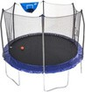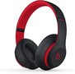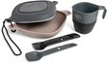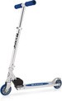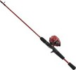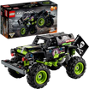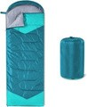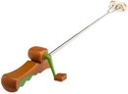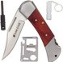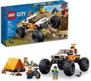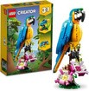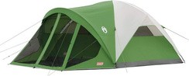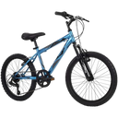

20

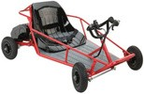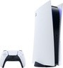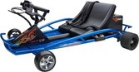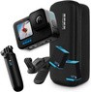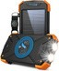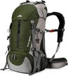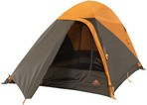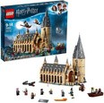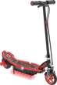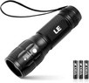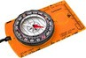

**THE DISPLAYED PRIZES ABOVE ARE NOT DELIVERED BY CAMP MASTERS OR THE INDIAN NATIONS COUNCIL. THESE ARE SUGGESTED PRIZES OR PRIZE IDEAS TO BE PURCHASED ON AMAZON.COM WITH YOUR GIFT CARD IF AVAILABLE. ACTUAL COSTS OF PRIZES ARE ESTIMATES, SUBJECT TO CHANGE, AND DON’T INCLUDE APPLICABLE TAXES AND SHIPPING.**

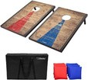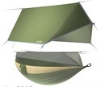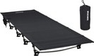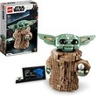

Guidelines for Indian Nations Council Rewards:

1. Prize level earned based on individual sales. No combining of sales with other Scouts.
2. Rewards are not cumulative and Scouts must reach or surpass stated sales total to be eligible for the Amazon.com Gift Card amount stated at that level.
3. Sell any item to receive the 2024 Popcorn Sales Patch.
4. Prize level total based off of the Scout’s total sales from Show & Sell, Take Order, AND Online.
5. Amazon Gift Cards will be given to your Unit Popcorn Chair.

Sell $1,500 to earn an invite for a special party & a chance to win an Amazon Gift Card for up to

$1,500 Club Victory Party



**$1,000!**

**EVERYONE WINS!!**

**Gift card values range from $50-$1,000! The more you sell, the more chances you have to win multiple gift cards.**

**Saturday, December 7, 2024**

###### Check-In: 11:00 am, Drawing: 12:00 pm (Must be present to win)

Scouts will receive: Incredible Pizza Buffet & Drink

$5 Game Card

**The Indian Nations Council will cover the cost (Entry, Buffet & Drink) for 1 Adult Partner to join the Scout at Incredible Pizza Company.**

21



**IN ADDITION to Council incentives, CAMP MASTERS oﬀers Prizes to recognize Scouts Popcorn Sale eﬀorts.**

Camp Masters Incentives

The Camp Masters High Achiever Prize Form can be found online at [www.campmasters.org/high-achiever-prizes.](http://www.campmasters.org/high-achiever-prizes) The form must be filled out and submitted to earn these incentives.

If your Scouts would like to receive the VISA gift card mentioned below at the $1500 Club Party, please submit the High Achiever Form along with the Council Prize Order Form by Tuesday, October 22nd at 5 pm.

**SELL $400+ ONLINE** GET A $10 AMAZON GIFT CARD

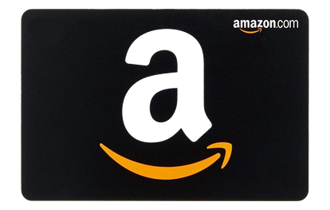

**SELL $3000+ TOTAL**

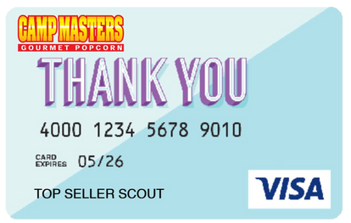

###### GET 4% BACK ON A VISA or

E-Gift card

**OR**

**THIS CAMPING PACKAGE**

2-Person Tent, 2L Hydration Pack, 6 in 1 Camp Tool, 5pc Stainless Steel Mess Kit w/ bag, and an Aluminum Safety Flashlight



Indian Nations Council

Redbud District

Brandon Gawel

Field Director/ Popcorn Staff Advisor

IMPORTANT CONTACTS

(918) 392-1237

[bgawel@okscouts.org](mailto:bgawel@okscouts.org)

Brenda DeShurley

Popcorn Staff Support (918) 392-1230

[popcorn@okscouts.org](mailto:popcorn@okscouts.org)

## Camp Masters

[www.campmasters.org](http://www.campmasters.org/) ordering.campmasters.org [customerservice@campmasters.org](mailto:customerservice@campmasters.org)

Justin Haralson

District Popcorn Kernel [jharalson89@gmail.com](mailto:jharalson89@gmail.com)

Kersten Nagle

Redbud District Executive

[Kersten.nagle@scouting.org](mailto:Kersten.nagle@scouting.org)

Mazie Lancaster

Redbud District Executive

[Mazie.lancaster@scouting.org](mailto:Mazie.lancaster@scouting.org)

Scissortail District

Acie Douglas

Scissortail District Executive [adouglas@okscouts.org](mailto:adouglas@okscouts.org)

Will Rogers District

Jodi Jakubek

District Popcorn Kernel

Jjakubek0881@gmail.com

Casey Garrett

Will Roger District Executive [cgarrett@okscouts.org](mailto:cgarrett@okscouts.org)